GitHub Repository:
https://github.com/2603466/WeeklyLabs

Docker Mount & Run:
docker run --rm -it -v "${PWD}:/app" -w /app python:3.11-slim python auditor.py
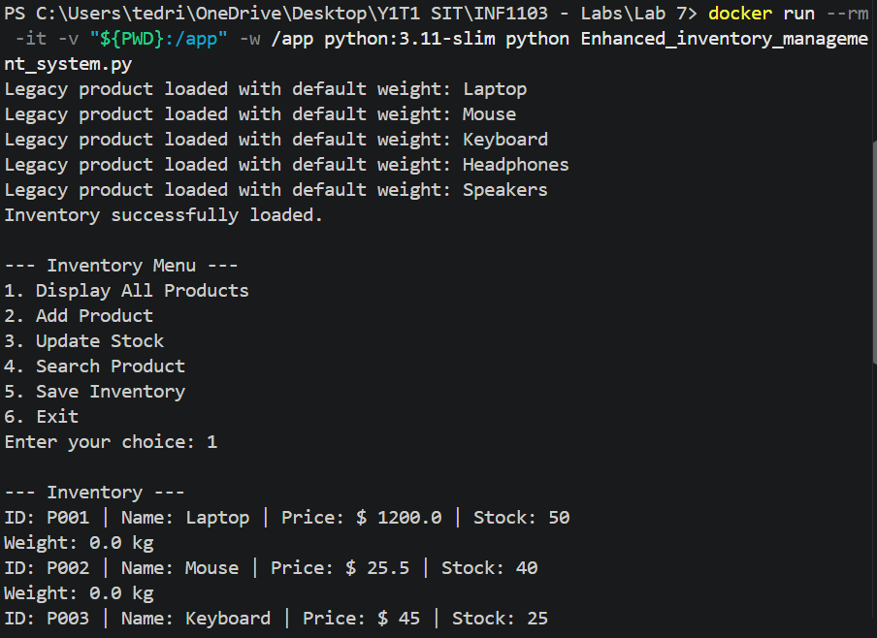
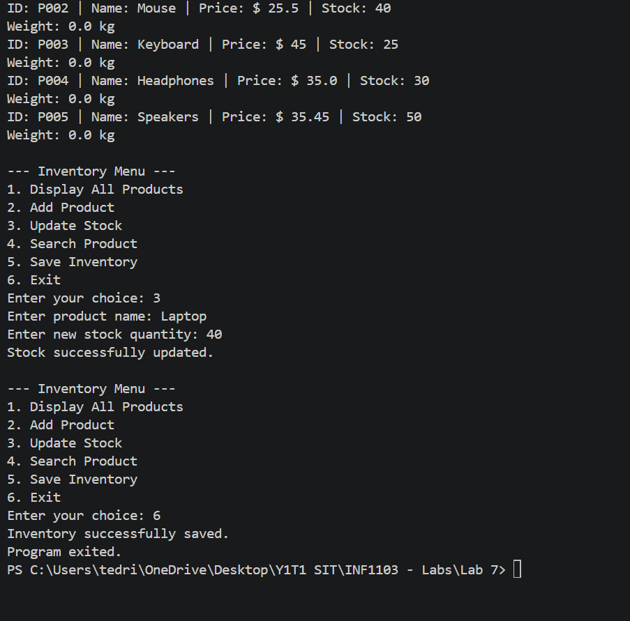

Docker Build:
docker build -t inf1103-labs-oop-inventory-management-system .
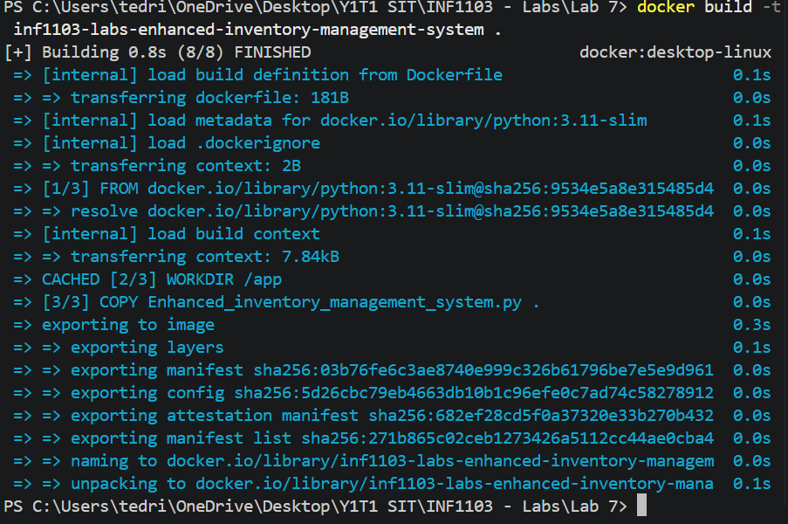

Docker Images:
docker images
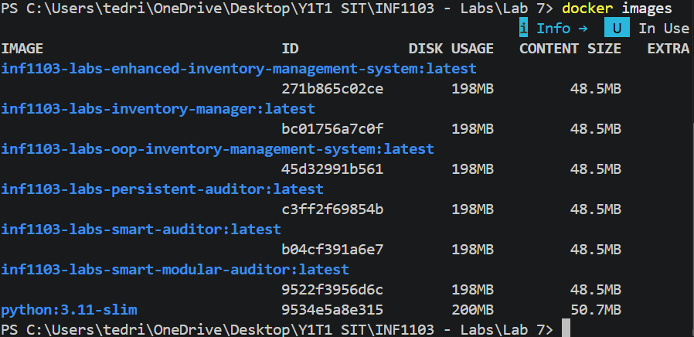

Proof that image runs:
docker run --rm -it inf1103-labs-inventory-manager


